Task 1.2: Exploratory Data Analysis
National Electricity Grid Network Analysis — Team Member 2 (Data Analyst)

Objective
Understand the characteristics of the utilities, substations, and lines datasets, and identify initial patterns in the Ghanaian grid network to guide the deeper network and business-intelligence analysis in Week 2.

1. Dataset Overview
The dataset was generated using the seeded script provided in the project brief (random.seed(42)), producing three related tables:
- utilities.csv — 10 rows (electricity utilities operating in Ghana and neighbouring countries)
- substations.csv — 44 rows (grid substations across Ghana's regions plus cross-border interconnection points)
- lines.csv — 55 rows (transmission/distribution lines connecting substations)

2. Descriptive Statistics — Numerical Variables
Substations:
Metric | Voltage (kV) | Capacity (MVA) | Commissioning Year
Mean | 134.5 | 157.9 | 1996.3
Std Dev | 120.4 | 139.9 | 16.1
Min | 11 | 6.4 | 1967
Median | 69 | 108.6 | 1999.5
Max | 330 | 487.6 | 2022

Lines:
Metric | Voltage (kV) | Length (km) | Capacity (MVA)
Mean | 141.4 | 99.3 | 222.4
Std Dev | 135.2 | 90.3 | 109.2
Min | 11 | 3.8 | 32.9
Median | 69 | 75.9 | 229.9
Max | 330 | 426.0 | 506.3

3. Frequency Distributions — Categorical Variables
- Substation Type: Transmission (21), Distribution (15), Bulk Supply Point (8)
- Substation Status: Active (43), Inactive (1)
- Line Status: Active (53), Under Maintenance (2)
- Line Type: Overhead (40), Underground (15)
- Greater Accra has the most substations (6), followed by Ashanti (5); several cross-border regions have exactly 1 each

4. Top Utilities by Number of Lines Operated
Utility | Type | Line Count
GRIDCo | Transmission | 24
NEDCo | Distribution | 14
ECG | Distribution | 10
CEB | Transmission | 3
CIE | Distribution | 2
SONABEL | Distribution | 2

GRIDCo, Ghana's national transmission utility, operates nearly twice as many lines as the next-largest operator (NEDCo), which is expected given its role as the backbone transmission company connecting regions and borders.

5. Most-Connected Substations
Substation | Region | Voltage (kV) | Connections
Kumasi Central | Ashanti | 161 | 5
Mallam | Greater Accra | 330 | 5
Cape Coast | Central | 69 | 5
Tema | Greater Accra | 330 | 4
Legon | Greater Accra | 161 | 4

Kumasi Central, Mallam, and Cape Coast are the network's most-connected 'hub' substations, each with 5 direct lines — these are strong early candidates for the critical-substation analysis in Task 2.1.

6. Geographic Distribution
Greater Accra leads in both substation count (6) and line count (11 lines by source substation), consistent with it being Ghana's most urbanized, highest-demand region. Ashanti (Kumasi area) is the second-largest hub. Upper West and most cross-border points have only a single substation each, suggesting thinner, more fragile connectivity at the network's edges.

7. Voltage-Level Distribution
Substations are fairly spread across voltage tiers: 11kV (9), 33kV (6), 69kV (8), 161kV (11), 330kV (10) — the 161kV and 330kV transmission tiers together make up nearly half of all substations, reflecting the transmission-heavy nature of the synthetic network.

8. Visualizations
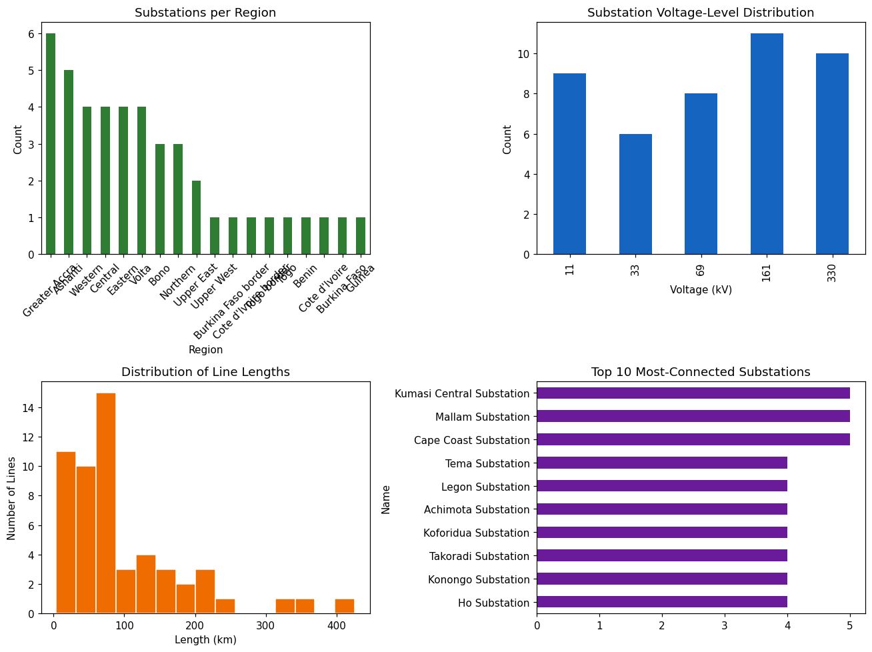

9. Initial Hypotheses About Network Structure
- Greater Accra and Ashanti will likely dominate centrality metrics in Task 2.1, since they have the most substations and connections.
- Border-interconnection substations, despite high voltage/capacity, may act as structural bottlenecks (single points of connection) — worth checking in the N-1 contingency analysis.
- GRIDCo's heavy involvement in inter-regional backbone lines suggests it will score highest on betweenness centrality, not just degree centrality.

10. Patterns for Further Investigation
- Only 1 substation is Inactive and only 2 lines are Under Maintenance — worth flagging as a reliability question in Task 2.3 (is this realistic, or does it understate maintenance backlog?)
- Wide spread in line length (3.8km to 426km) — categorizing into short/medium/long transmission runs (Task 2.2) may reveal regional vs. cross-border patterns.
- Capacity variation is large (6.4–487.6 MVA) — worth checking which substations are operating close to rated capacity as upgrade candidates (Task 2.3).

